A LEVEL AGRICEULTURE PAPER 3

* **Aphids**, **piercing and sucking pests**; these pierce crop tissue and suck fluids. E.g Thrips, aphids, scaly insects, mealy bugs, cotton stainer seed bugs, cotton leaf hoppers, 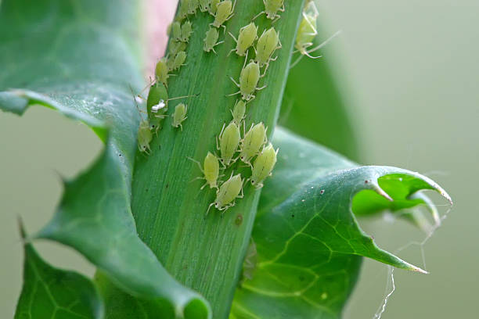

**Describe the mouth parts of each specimens**

* Has Pointed stylet, needle like mouth part
* Aphids has piercing sytlets for sucking sap from crops
* Has dull colour for comflouge
* Small in size to increase surface area for food absorption
* Has wings for flight from predators

**Effects of sucking pests on crops**

* Transmit pathogens to crops
* Inject toxic saliva into crops affecting growth
* Create entry points for pathogens into crops
* Suck sap from crops causing wilting and stunted growth
* **Worker termite,**

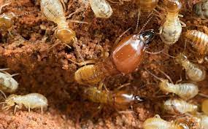

* These have strong mouth parts that they use to bite and chew crop parts. Examples are termites,crikets grass hoppers, locusts, caterpillars, rodents, weevils, bean bruchids, e.t.c
* Has Pair of jaw like mouth parts/pair of cutting mandibles/pair of strong mandibles pair of cutting mandibles/strong mandibles/pair of saw-like mouth parts)
* **Describing** **the damage caused by each specimen on crops or crop production.**

**termite**

* Cut/eat plant tissues/stems/roots reducing yields
* Eat products in store reducing yields
* Reduce crop quality
* Causes wounds on plants that act as entry point for pathogens

**aphid**

* Sucking plant sap/juices leading to wilting
* Introduction of toxic saliva in plants
* Transmits disease causing organisms in plants especially viruses
* Reduction in quantity of crop yields.
* Defoliation/leaf fall lowering the rate of photosynthesis
* **Give one method of controlling each specimen**.

**termites**

* Dig the anthill, remove and kill the queen.
* Apply termicides in the anthill to kill the termites and the queen.

**aphids**

* Spraying with recommended insecticide/pesticide
* Cultural methods e.g. crop rotation, proper spacing, timely planting, close spacing in g/nuts**)**
* **Give four reasons why the termites and aphids are very successful in their mode of life**.
* High mobility to search for food
* Small size not to be easily seen
* Highly prolific (producing at high rate)
* Camouflage to avoid enemies
* Feeding on a variety of food
* High ability to locate food
* **Effects of pests on crops**.
* Eat planted seeds in soil reducing viability
* Eat crop roots causing plants to fall or wilt
* Eat crop leaves reducing photosynthetic capacity of crops
* Tunnel through stems weakening it
* Make holes in root tubers leading to rotting
* Suck crop sap leading to wilting
* Can eat crops completely
* Can transmit crop diseases
* Eat crop flowers causing low yield
* Bore into fruits and causes rotting
* Scratch fruits reducing their quality
* **Indirect effects of pests in crop production**
* Cause famine and suffering to humans by destroying food crops
* Increase costs of production in agriculture through buying pesticides
* Cause stunted growth in crops
* Reduce quality of crop products affecting prices
* Cause annoyance to farmers
* Can cause poverty to farmers
* Chemical control of pests can cause environmental pollution
* Some new pest species can come up when chemicals are used to control pests
* **Cultural pest control**
* Using planting materials that are free from pests to control spread and establishment
* Removal of infected crops from the garden to minimize spread of pests
* Practicing crop rotation that breaks the life cycle of pests
* Planting crops on time so that they can escape pests that come late in the season
* Timely harvesting which reduces pest damage to crop products
* Planting pest resistant varieties of crops. Resistance can be pseudo or real.
* Use of trap crops that help in eliminating the pests
* Practicing close seasoning where community can be easily mobilized
* **Drenching gun**

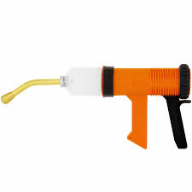

* It is used to administer oral treatment to animals to control internal parasites like liver flukes, round worms, tape worms, hook worms.

**Features of drenching gun**

* Has nozzle for passage of the drug
* Has calibrated container for storage of the drug
* Has a handle for firm grip
* Has a trigger for exerting pressure to the drug
* **Describe the procedure followed when using drenching gun.**
* Restrain the animal
* The head of animal is lefted sothat the mouth is raised to avoid medicin to flow it
* Fingers are inserted in one side of the mouth just behind the dental part and the thump is placed of the noise.
* The mouth of the bottle or delivery tube of the drenching is inserted into the calfs mouth
* The medicine is than poured in the mouth slowly and steadly as the animal swallows it.

Burdizzo

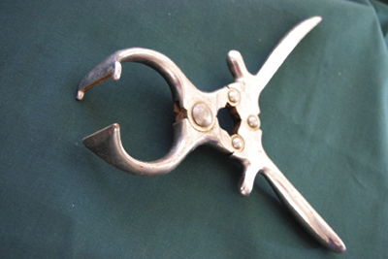

**Describe the procedure how the burdizzo is used for castration.**

* Restrain the animal using ropes and cast it down.
* Pull the scrotum down wards to locate the spermatic cords, ducts and nerves
* Open the jaws of the burdizzo by pressing the handles out-wards
* Place the burdizzo at the “neck” of the scrotum
* Press the handles of the burdizzo in-wards to lock the jaws and crush the spermatic cords, blood vessels and the nerves.
* Open the jaws of the burdizzo and remove it from the crushed area
* Release the animal (Oxen) after the operation
* Keep the animal within reach for easy supervision
* **Identify the features on the burdizzo that enable it to perform its function**
* Has blunt jaw used to crush spermatic cord?
* Has handles for holding/firm grip
* Has a joint for easy flexibility.
* Its coated with steel to prevent rusting
* **Dehorning iron**
* Dehorning iron is heated until it is red hot and pressed on the horn bud.

**Procedure of Dehorning iron**

* Restrain the animal in a crush
* Heat the Dehorning iron in fire or gas until red hot
* Hot ron tip is pressed on top of the horn sothat the horn bud or tissue are burnt including the vessels to avoid any further growth.
* Release the animal from the crush
* **Reproductive system of a male animal**

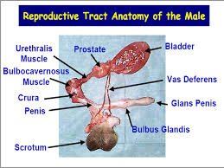

* **Scrotum.**
* It is a double sac containing the testes which is a pouch formed by the weight of the testes.
* It supports the testes.
* It regulates and maintains the temperature suitable for the testes to produce sperms below normal body temperature.
* It protects the testes**.**
* **Testes.**
* The testes produce male sex hormones ( androgens) mainly testosterone, therefore, the testes perform cytogenic(cell producing) and endocrine(hormone secreting) functions.
* **Epididymis.**
* it stores the sperms and allows them to mature further before ejaculation**.**
* **Sperm duct(vas deferens).**
* It channels the spermatozoa from the epididymis to the urethra**.**
* **seminal vesicles**
* They secrete seminal fluids that mix with spermatozoa to form semen.
* The fluids secreted include fructose that act as source of energy for the sperm cells.
* **Cowper’s glands**
* They secrete bulbo-urethra for cleaning the urethra free of urine and to lubricate the semen.
* **The seminal fluids have the following functions**.
* They provide energy to sperms
* They dilute the sperms
* They protect sperms against any toxic substances.
* They provide a medium for nutrition of sperms
* **Penis**.
* It is a spongy erectile tissue that become filled with blood during erection.
* It is used for mating and urination.
* **Bean seeds of varying sizes and colour mixed with foreign materials.**

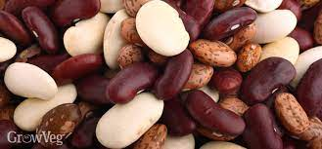

* **Qualities for good seeds for planting**.
* The seeds be free from pests and diseases
* They should be free from mechanical damage.
* They should have correct moisture content
* They be fertilized i.e. it must have gone through pollination process
* They have good size, to have good food reserve
* They should be clean i.e. free from contamination by weeds, soil
* They should be plumb and well filled.
* **Banana sucker with some soil on the roots**

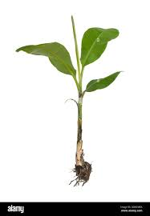

**Describe how the banana sucker is planted**

* Remove perennial weeds
* Make holes 60cm deep and 60cm wide
* Place some manure e.g farm yard in the hole
* Add phosphate fertilizer to improve on rooting and rhizome establishment.
* Planting is done at the beginning of the rain
* Place the suckers in the holes and fill up with top soil.
* **A whole pineapple plant with a fruit, sucker, slip and crown**

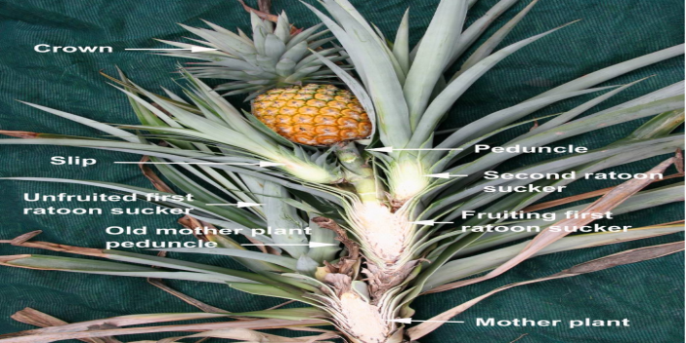

**Blood meal**

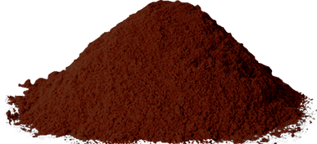

* **Minerals supplied to poultry**
* Iron
* Phosphorus
* Calcium
* Zinc
* proteins
* **How blood meal is made for poultry feed,**
* blood should be collected from abattoirs.
* It is then boiled while stirring constantly to reduce moisture content.
* it should be spread on a clean surface and allowed to sun-dry or oven-dry
* it is mixed with other feeds and fed to poultry.
* **molasses**

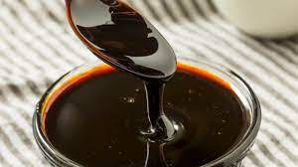

* **How molasses is made**
* the sugar cane is crushed and the juice is extracted.
* The juice is then boiled to form sugar crystals and removed from the liquid.
* The thick, brown syrup left after removing the sugar from the juice is molasses.
* This process is repeated several times to produce a different type of molasses each time.
* **Molasses is a good source of**
* iron,
* selenium,
* copper,
* calcium
* **mineral lick**

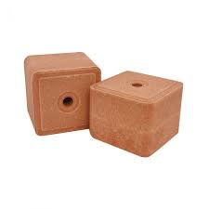

**Nutrients supplied**

* calcium
* phosphorus
* potassium
* iodine
* sodium
* iron
* zinc
* **Function of minerals in the body of animals**
* They are constituents of tissues such as blood, bones and teeth.
* They take part in speeding up chemical reactions within the body by acting as co-enzymes.
* They regulate the osmotic properties of body fluids e.g. blood.
* They serve as components of enzymes and hormones.
* They are components of animal products.
* They are components of certain pigments in the body e.g. iron in hemoglobin, copper in melanin
* **Rhode grass**

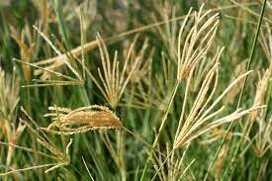

* Urea fertilizer

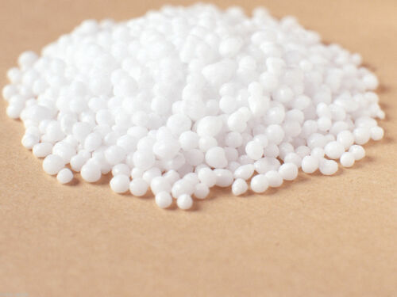

Advantages of using urea

* Has high nitrogen content
* The cost of urea production is low
* Wide application, urea can be applied to all types of crops and soil
* Disadvantages of using urea
* It is very soluble in water and hygroscopic water,
* it reguires better storage
* it requires skill labour to apply
* urea should be applied at the time of planting, broadcasting.
* **Green leaf Desmodium**

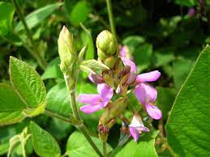

**What observable features make Green leaf desmodium and Rhodes grasssuccessful in their habitats**?

**Green leaf Desmodium**

* Hairy leaves that prevent being grazed on
* Fibrous roots for water and nutrient absorption
* Large leaves for photosynthesis
* Succulent stems and leaves to prevent drying
* Seeds for propagation
* Stems with nodes and buds that grow into new plants

**Rhodes grass;**

* Viable numerous seeds for propagation
* Fibrous roots for water and nutrient absorption
* Numerous leaves for photosynthesis
* Many tillers for propagation
* Narrow leaves to minimize water loss.

**Classify the specimens into two named groups / broad families, giving reasons for your classification in each case.**

|  |  |  |
| --- | --- | --- |
| **Specimen** | **Crop family / group** | **Characteristics/reasons.** |
| Green leaf  desmodium | -Leguminaceae (Legume family) | -Network venation.  –Broad leaves.  -Tap root system.  -Pods with seeds.  -Root nodules |
| Rhode grass | -Gramineae (Grass family) | -Parallel venation.  –Narrow leaves.  -Fibrous root system.  –Seeds in form of grains |

END